**Name: Anish Ashok Sharma Sap id: 60003220045**

**Branch: Information Technology Div: D/IT1**

**Course**: **Object Oriented Programming using Java**

# Experiment no. 7

Aim: To implement Inheritance

**Problem Statement 1:**

WAP to demonstrate the role of Constructors in inheritance in the following class diagram:

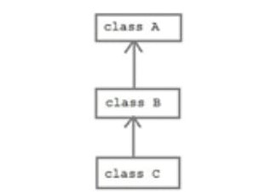

Code:

class A

{

int a=10;

public A()

{

System.out.println("Feature 1");

}

}

class B extends A

{

public B()

{

System.out.println("Feature 2");

}

}

class C extends B

{

public C()

{

System.out.println("Feature 3");

}

}

public class InheritanceConstructor

{

public static void main(String []args)

{

C obj1=new C();

}

}

Output :

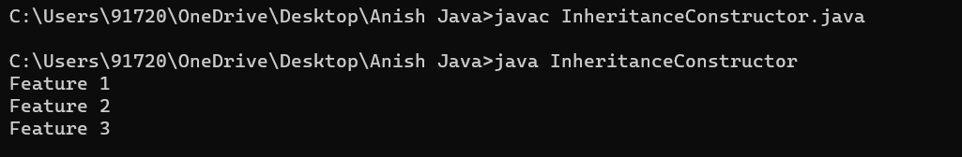

**Problem Statement 2:**

Display data of the specialized classes given in the following class diagram.

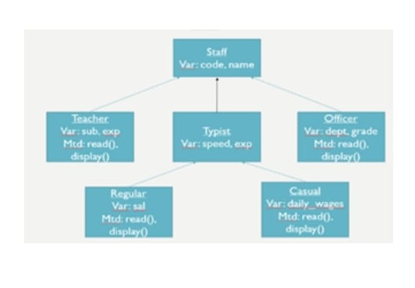

Code:

import java.util.*;

class Staff

{

Scanner sc=new Scanner(System.in);

int code;

String name;

}

class Teacher extends Staff

{

int exp;

String sub;

public void read()

{

System.out.println("Enter Name");

name=sc.nextLine();

System.out.println("Enter Code");

code=sc.nextInt();

System.out.println("Enter Experience");

exp=sc.nextInt();

sc.nextLine();

System.out.println("Enter Subject");

sub=sc.nextLine();

}

public void display1()

{

System.out.println(code+" "+name+" "+sub+" "+" "+exp);

}

}

class Typist extends Staff

{

int speed;

int exp;

}

class Regular extends Typist

{

int sal;

public void read()

{

System.out.println("Enter Name");

name=sc.nextLine();

System.out.println("Enter Code");

code=sc.nextInt();

System.out.println("Enter Experience");

exp=sc.nextInt();

System.out.println("Enter Speed");

speed=sc.nextInt();

sc.nextLine();

System.out.println("Enter Salary");

sal=sc.nextInt();

}

public void display2()

{

System.out.println(code+" "+name+" "+speed+" "+" "+exp+" "+sal);

}

}

class Casual extends Typist

{

int dailyWages;

public void read()

{

System.out.println("Enter Name");

name=sc.nextLine();

System.out.println("Enter Code");

code=sc.nextInt();

System.out.println("Enter Experience");

exp=sc.nextInt();

System.out.println("Enter Speed");

speed=sc.nextInt();

System.out.println("Enter daily Wages");

dailyWages=sc.nextInt();

}

public void display3()

{

System.out.println(code+" "+name+" "+speed+" "+" "+exp+" "+dailyWages);

}

}

class Officer extends Staff

{

String grads;

String dept;

int sal;

public void read()

{

System.out.println("Enter Name");

name=sc.nextLine();

System.out.println("Enter Code");

code=sc.nextInt();

sc.nextLine();

System.out.println("Enter Department");

dept=sc.nextLine();

System.out.println("Enter Grades");

grads=sc.nextLine();

System.out.println("Enter Salary");

sal=sc.nextInt();

}

public void display4()

{

System.out.println(code+" "+name+" "+dept+" "+grads);

}

}

class MultilevelStaff

{

public static void main(String[] args)

{

Teacher obj1=new Teacher();

obj1.read();

obj1.display1();

Regular obj2=new Regular();

obj2.read();

obj2.display2();

Casual obj3=new Casual();

obj3.read();

obj3.display3();

Officer obj4=new Officer();

obj4.read();

obj4.display4();

}

}

Output:

